**MYSQL DATABASE ON UBUNTU**

Note: this tutorial will show you how to install mysql and create a database on your ubuntu server. If you had done the how to set up back end tutorial, you will have Ubuntu server install on your machine. If you don’t have Ubuntu install on your machine, please look at my “HOW TO RUN THE BACKEND CODE.docx”

Step 1 : Type “sudo apt-get update” and hit enter

Step 2 : Type “sudo apt-get upgrade” and hit enter (restart your computer after this step)

Step 3 : Type “sudo apt-get install mysql-server” and hit enter

This will install mysql-server on your machine

Step 4: Type “sudo service mysql start” and hit enter

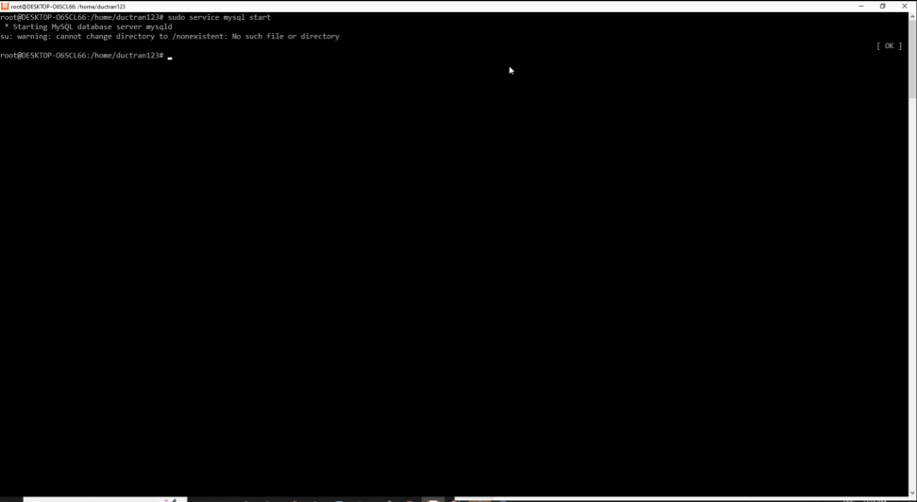

Step 5: Enter mysql command line by typing “sudo mysql” and hit enter

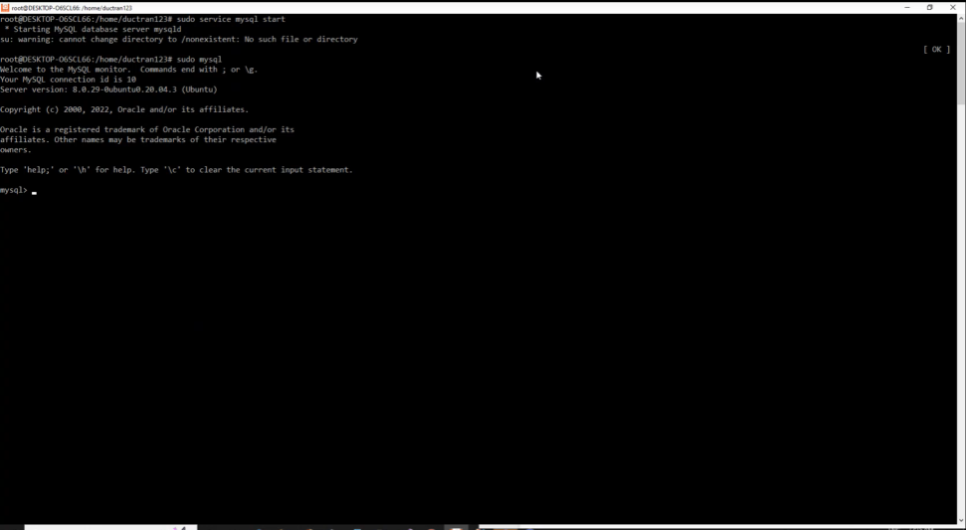

Step 6: Change the root user password by Type “ALTER USER ‘root’@localhost IDENTIFIED WITH mysql_native_password by ‘yourpasswordhere; ” and hit enter.

Step 7: Restart mysql database to apply the password change “sudo service mysql restart” and hit enter

Step 8: Secure install mysql by typing “sudo mysql_secure_installation”

The list of prompts you need to enter will be in this table.

|  |  |
| --- | --- |
| Prompt | Answer |
| “Enter password for user root:” | Enter the password you choose in step 6 |
| Would you like to setup VALIDATE PASSWORD component | Yes |
| “Please enter 0 = LOW, 1 = MEDIUM and 2 = STRONG:”. | 0 |
| “Change the password for root ? ” | yes |
| “New password:” and “Re-enter password:” | Enter the password you choose in step 6 |
| “Do you wish to continue with the password provided?” | yes |
| “Remove anonymous user ?” | no. |
| “Disallow root login remotely” | no |
| “Remove test database and access to it?” | no |
| Reload privilege table now? | yes |

That is all. Mysql is set up. To use the mysql command line type “mysql -u root -p” hit enter and enter your password

The next few steps will show you how to create a database and connect with the database

Step 9: Create database by enter “CREATE DATABASE <database name>;”. Enter “SHOW DATABASES;” to see the database you’ve created

Step 10: As I mentioned in the postscript of “HOW TO RUN THE BACKEND CODE.docx”, at this time the aws database would have been shutdowned. If you want to use the user_services, you need to change the database url, it is done by changing the application.properties file.

As you can see there are one for each service. The one you need to change is in user_services since data_services does not need a database.

Here is the format

Change the <field> with the correct variables name. After that you can run the app like normal.

Database_name : the name of the database you choose in step 9

Your_username: root

Your_password: Enter the password you choose in step 6

Example:

**THANK YOU FOR READING THIS TUTORIAL**